**Experiment 1**

**Aim:** Gray/ Intensity level resolution

**Code:**

from skimage import data

from skimage import io

from skimage.color import rgb2gray

import matplotlib.pyplot as plt

image = data.astronaut()

#print (image)

#io.imshow(image)

img_gray = rgb2gray (image)

img_gray = img_gray * 255

img_reso = img_gray.copy()

b= 1

num_levels = 2**b

step_size = 256//num_levels

print (step_size)

sh = img_reso.shape

print (sh)

for r in range (0,sh[0]):

for c in range (0,sh[1]):

temp = img_reso[r][c]

for i in range (0,num_levels):

if temp >= i*step_size and temp < (i+1)*step_size:

img_reso [r][c]=i*step_size

break

plt.figure()

plt.figure(figsize=(7,7))

plt.subplot (2,1,1)

io.imshow (img_gray, cmap='gray')

plt.title ('Original Image')

plt.subplot (2,1,2)

io.imshow (img_reso, cmap='gray')

plt.title ('Low Reso Image')

**Outputs:**

b=1

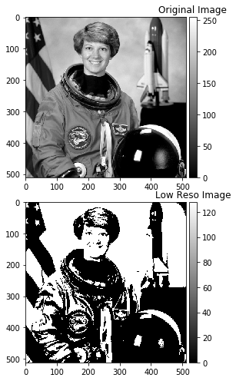

b=2

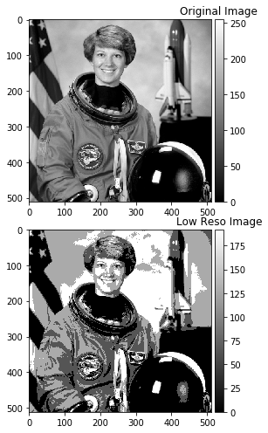

b=3

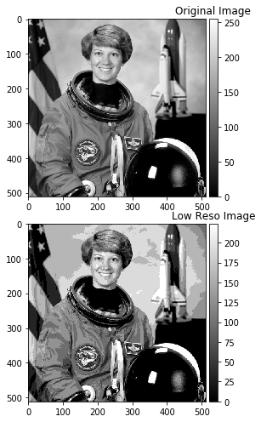

**Conclusion:** Larger the number of bits, better resolution. If only 1 bit is allotted, then we get binary image. Quality improves with increase in number of bits allotted to each pixel.